**CVOCD PCB Version 5 Assembly Instructions**

Note – these photos show the prototype board. Production boards will be supplied in panels of THREE boards arranged vertically with top and bottom support rails (per stencil files already provided). The production boards use black soldermask but have identical design/layout as prototypes shown below.

The following picture shows the board as it should appear following the reflow process (in this example the components have been soldered by hand)

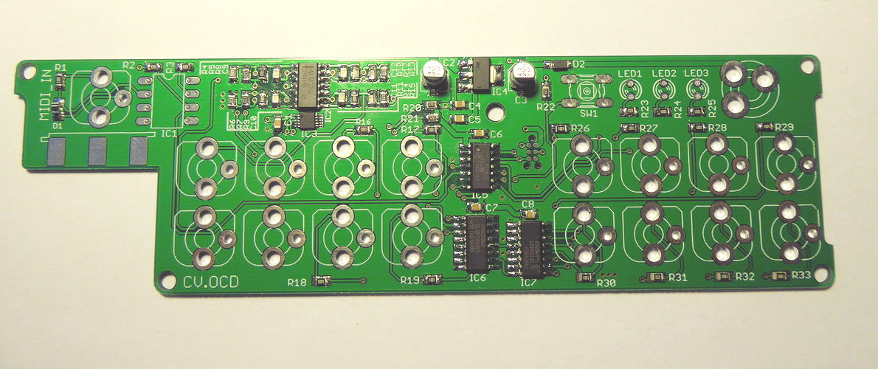

Some parts of the board will need to be masked during the wave soldering process since these parts will be added later when they can be built into the final device enclosure. The picture below shows in RED boxes the pads which should NOT receive solder during the wave process. All pads which require wave soldering are shown in the green boxed area.

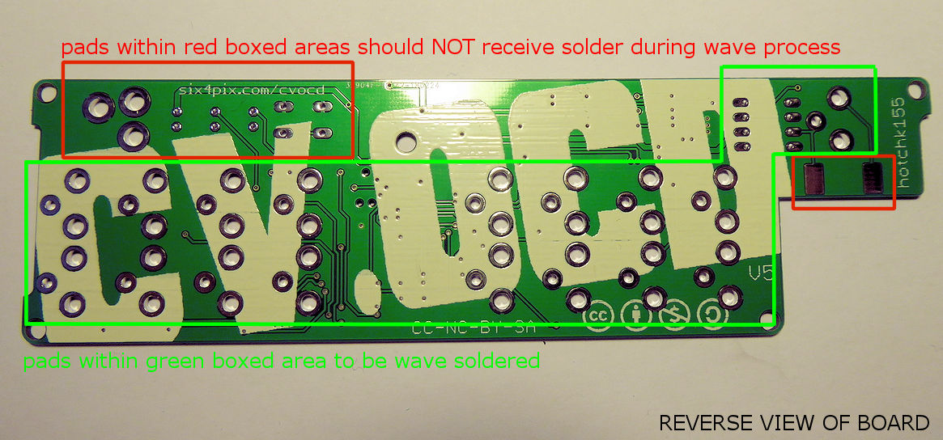

The following picture shows the top side of the board, indicating the position of the same areas that need to be masked on the underside of the board during the wave process.

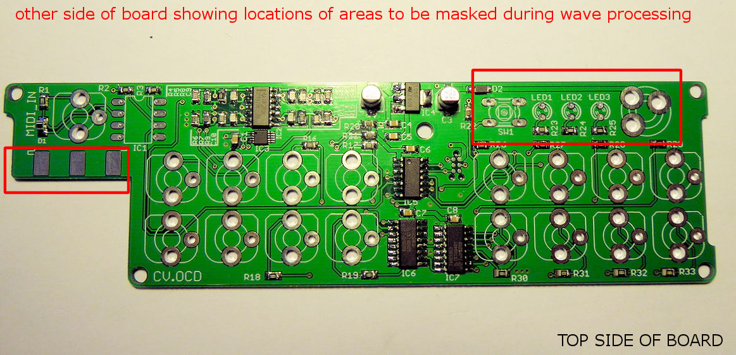

The following picture shows the components and locations that will be fixed by wave soldering. As listed on BOM these are 17 x 3.5mm vertical sockets and 1 x 6N138 opt-isolator IC in DIP-8 package.

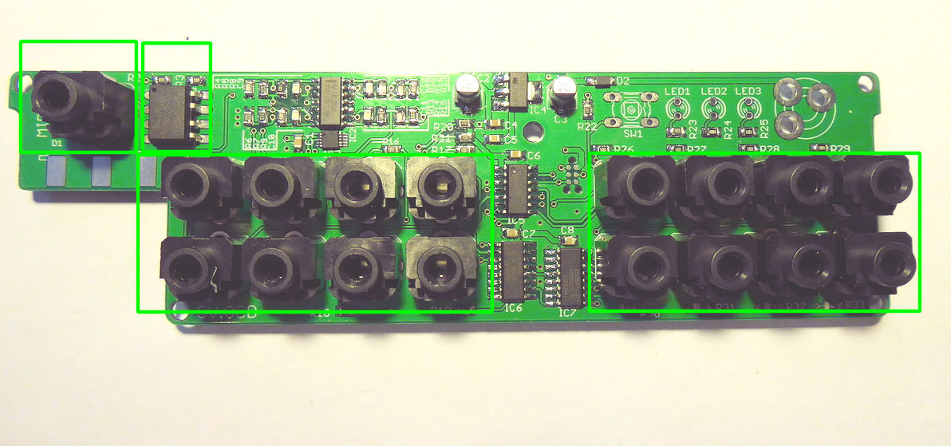

A laser cut acrylic face place will be provided that can be used as a guide for aligning the sockets

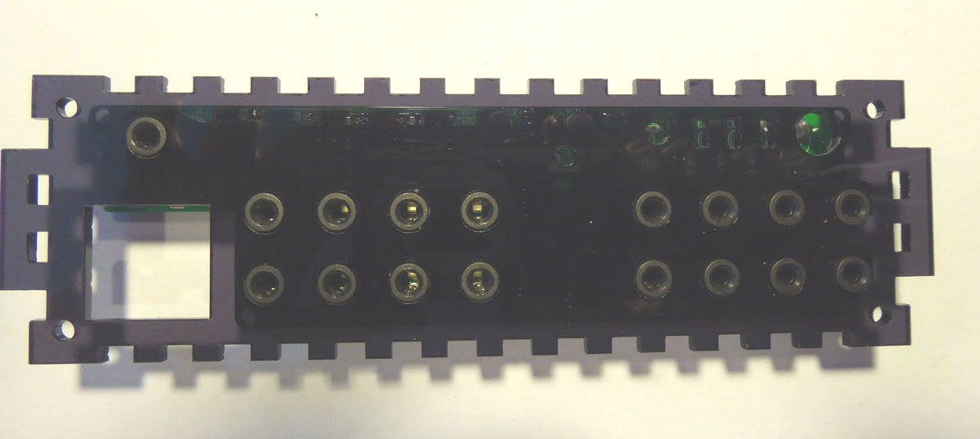

The following picture shows the solder joints to be made in the wave process

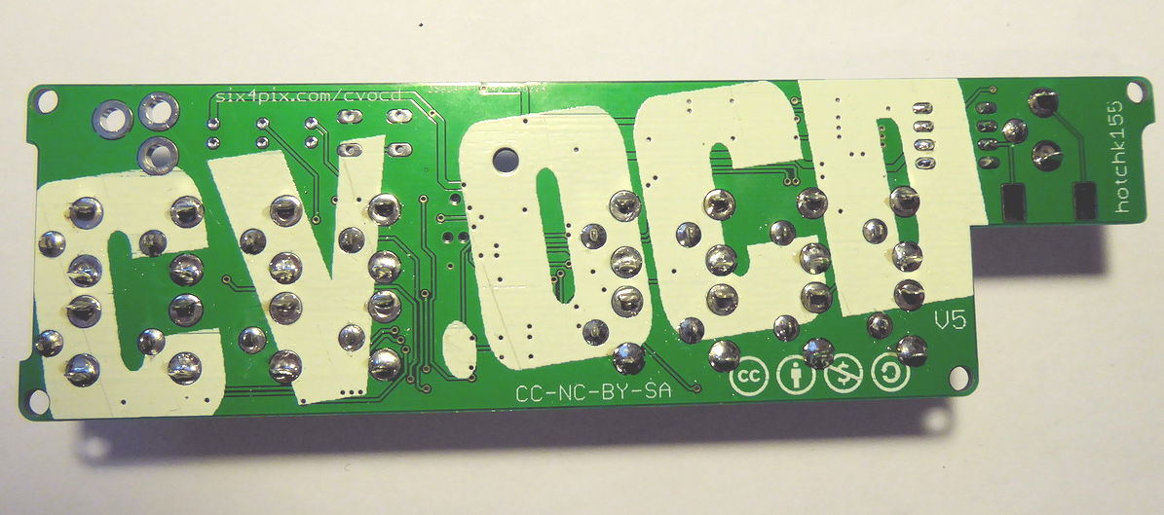

**The following locations on the board should remain unpopulated** (and should be free of reflow or wave solder deposits)

* Five rectangular pads (three on top side, two on bottom side) for edge connected DIN connector (far left of board, below MIDI_IN label)
* Two plated holes for switch SW1
* Six plated holes for indicators LED1, LED2, LED3
* Three large plated holes for DC power connector (unlabelled, to right of LED3)

For reference purposes a fully populated board (including the additional components) will be provided.

